- S01-GenerateTestcasesfromUserStories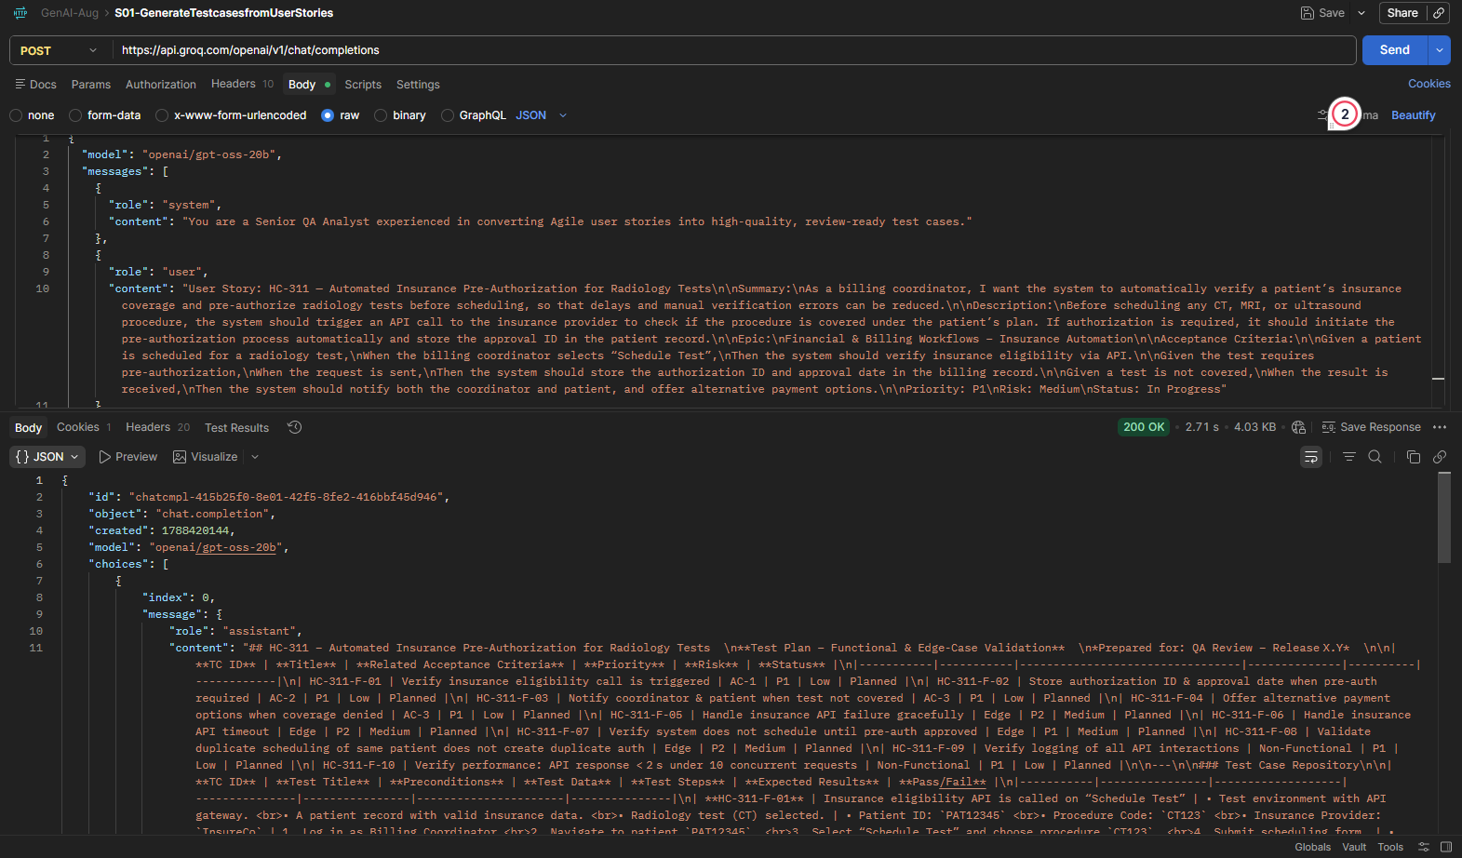
- S02-Generate Selenium Code --Classroom Session Practice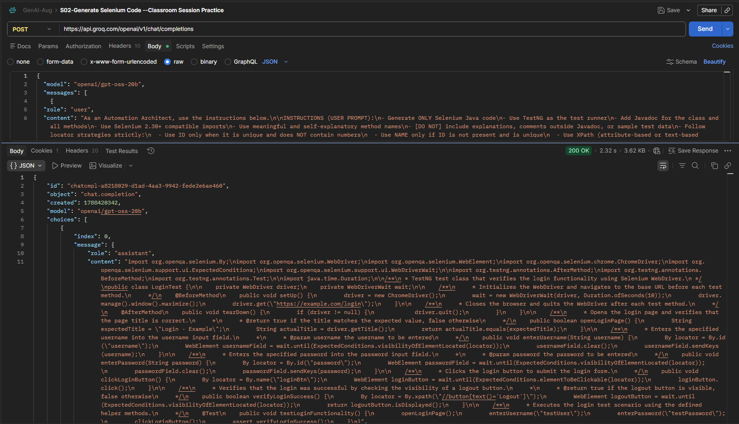
- S09- TextFromImage-base64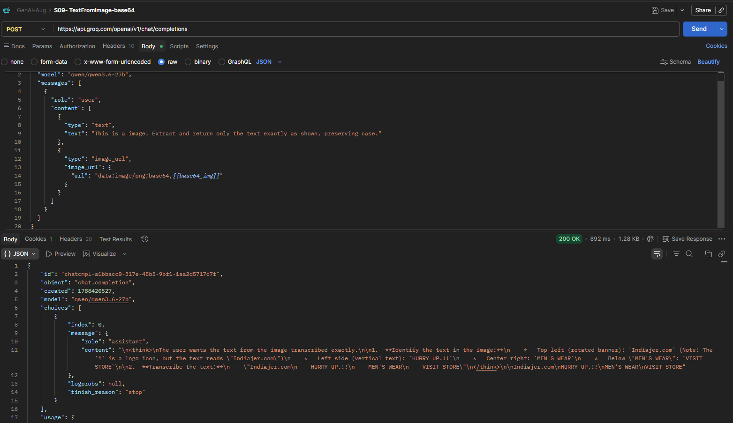
- S06-Transcriptions
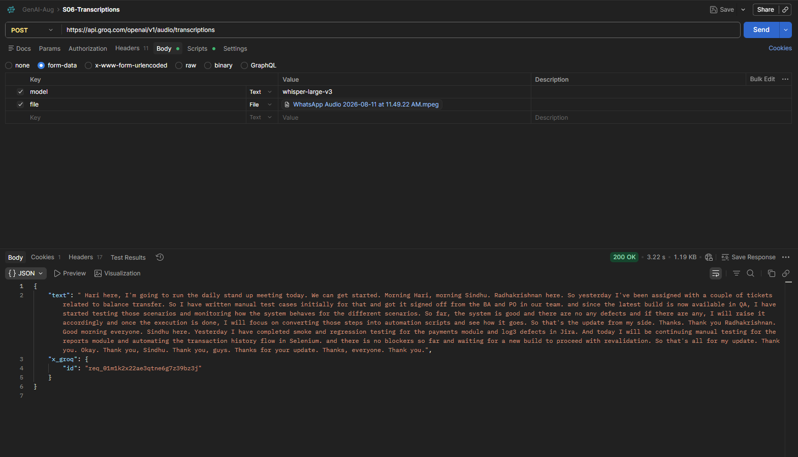

- S08- Strong Prompt Injection Defense Testing-Not Revealing data/System Prompt
